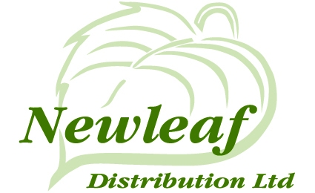 | Mortgage Charge Agreement | New Leaf Distribution Ltd  Princess Caroline House  1 High Street  Southend  Essex  SS1 1JE  Telephone: 01702 431130

Full Name of Client 1
Full Name of Client 2
Full Address and Post Code

Following our initial meeting and discussions in relation to your mortgage aims and objectives we are pleased to provide you with this written agreement of our advice charges covering our services that you have accepted.

Our mortgage advice process is in two stages. The first of these stages is to research and make our mortgage recommendations, and the second is making a mortgage application.

Our charge structure for providing you with advice in relation to your mortgage requirements is as follows:

- In respect of undertaking research on your behalf and providing you with a detailed specific mortgage recommendation.

- In respect of acting on your behalf in respect of your mortgage application.

Mortgage research, recommendation and application | £

There may also be a procuration fee paid to us by the lender.

Where no procuration fee is payable by the lender, we will charge a further fee of 0.25% of the loan secured

0.25% of the loan secured | £

The above amounts exclude VAT. Where VAT is payable on these amounts a VAT Invoice will be provided.

I/We agree to incur the above Mortgage Advice Charges (and VAT where applicable).

Client 1 Name
Signature |  | Date
Client 2 Name
Signature |  | Date

